Name:

CDN #:

Company:

Address:

Phone: Email:

Which courses are you applying to be an instructor (please circle)

DVPS
SSPV-CP
SSPV-NCP
SDV-BS
SVOP (must have 150 tonne ticket to apply)

Company Vessel(s) and Tonnage training to be conducted on:

Please explain why you would like to be designated a Marine Emergency Duties instructor.

What Certifications and tickets do you hold?

What is your Commercial Maritime Experience?

What other relevant experience do you possess?

Please describe your leadership and management experience.

Please describe your experience as an instructor. Have you taken any formal teaching courses. If so, please state.

What other skills do you possess that would improve your ability to be an instructor (ie technology, communication etc.)

Please describe any other information that would assist the PCVA and Transport Canada in evaluating your application.

Please submit your own Marine Emergency Duties certificates, your resume, as well as any other valid Transport Canada certifications, or teaching certificates you hold as outlined above.

Please submit specifics on the TC requirements listed below in 9.2 ie: course name, date, location, primary and supervising instructor, etc. Please attach a letter from the instructor who has overseen your teaching of requested courses.

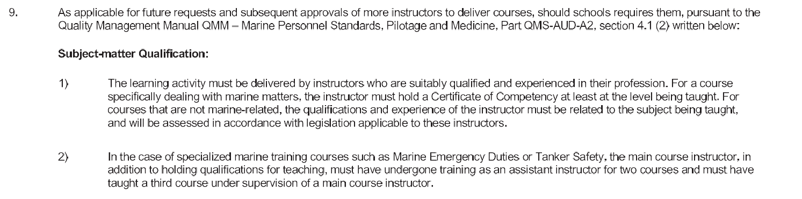

Please submit all documents to info@pcvacanada.ca

If you have any questions, please contact jill@pcvacanada.ca

Thank you!

